Introduction
The Noosa River is a valuable natural, social and economic asset to the people of the Noosa region and visitors alike. It is arguably south-east Queensland’s only substantially natural major river system due to the considerable areas of remnant vegetation retained within the catchment, and it consistently achieves the highest ratings in South-East Queensland in Healthy Land & Water’s Ecosystem Health Monitoring Program. The Noosa community have a deep understanding of the Noosa River and its catchment, shaped by decades of experience, and a shared interest in addressing and alleviating the pressures facing this highly-valued ecosystem, to ensure the intrinsic values of the Noosa River and its catchment remain.
The Noosa River is a complex waterway and management of this dynamic system involves multiple agencies across all three tiers of government (Local, State and Commonwealth) in managing different locations, impacts and activities on the river. With that understanding, the local Noosa Shire Council (NSC), and the State regulatory agency for coastal waters of Queensland, Maritime Safety Queensland (MSQ), have committed as co-chairs to a Noosa River Stakeholder Advisory Committee (NRSAC) with an aim to engage with local stakeholders and communities as an essential component in the management of the Noosa River and its catchment.

Purpose
The purpose of the Noosa River Stakeholder Advisory Committee (NRSAC) is to engage key community stakeholders to provide objective advice and recommendations towards the sustainable use, conservation and management of the Noosa River and its catchment.
NRSAC is not a decision-making body. Advice and recommendations provided by NRSAC to relevant management agencies are non-binding.

Objectives
The objectives of the Noosa River Stakeholder Advisory Committee:
- An equitable forum is provided for discussion of matters relevant to the management of the Noosa River that considers the ecological, social and economic sustainable use of the river and its catchment.
- Key issues and solutions for the Noosa River and catchment are prioritised and the community works collaboratively to implement relevant actions in a timely manner.
- Solutions to issues associated with the Noosa River are discussed and decisions made with all the available local information.
- There are clear lines of communication between management agencies and river user groups, and both understand the basis and breadth of each other’s views.
- The local Kabi Kabi (Gubbi Gubbi) are effectively engaged and bring a First Nations perspective to ongoing management of the Noosa River and its catchment.

Regional Distribution
The NRSAC will focus on regional issues and represent Noosa Shire community and stakeholders located throughout the Noosa River and its catchment as defined in Figure 1.

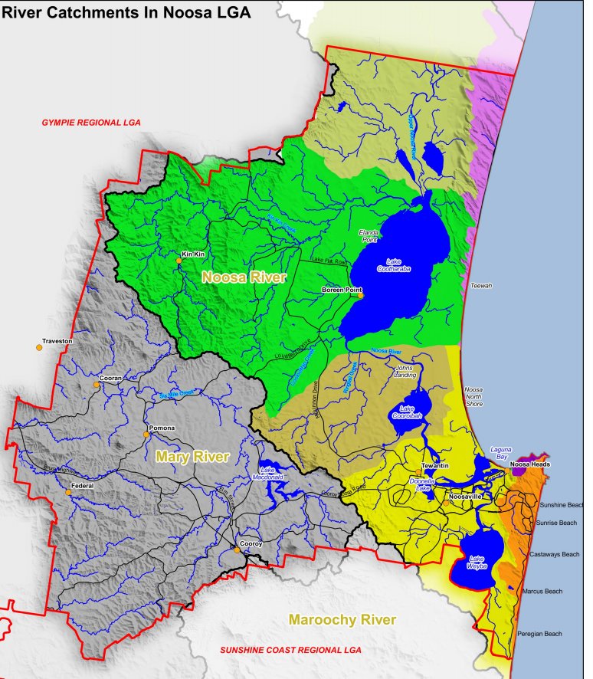

Noosa Shire Council
Noosa Shire Council will lead on catchment-related issues that impact the Noosa River. These will primarily be from land-based sources, where Council has a higher degree of responsibility and will include upper catchment impacts that affect the whole catchment. Council will make clear it’s priorities for river management through its policies, such as the Noosa Environment Strategy and Noosa River Plan. As these policies are up for review, the Noosa River Stakeholder Advisory Committee will provide input.

Maritime Safety Queensland
Maritime Safety Queensland will facilitate day-to-day waterways operations and management of the Noosa River especially in maintaining a safe and healthy waterway by helping to educate the recreational boaties and commercial operators on their safety and environmental pollution obligations, as well as enforcement of these obligations under Transport Operations Marine Safety Act 1994 and its regulation, the Transport Operations Marine Pollution Act 1995 and its regulation and the Transport Operations (Waterways Management) Regulation) 2012, of which MSQ is the regulatory agency.

Noosa River Stakeholder Advisory Committee Participants

Chair
The NRSAC will be co-chaired by a senior officer of Noosa Shire Council and Maritime Safety Queensland. The Noosa Shire Council Chief Executive Officer will appoint an officer of Noosa Council to sit as the NSC Chair. MSQ's General Manager, or their nominated representative, will have responsibility for the role of Chair.
Noosa Council will chair and lead discussion on catchment-related issues such as:
- Water quality monitoring, research and biodiversity in the river system
- Riparian management, specifically vegetation
- Land-based inputs into the river, such as pollution and sediment
- Stormwater management.
Maritime Safety Queensland will chair and lead discussion on issues related to the Noosa River management within the coastal waters of Queensland:
- Recreational boating users of the river
- Boating safety related matters of the river
- Ship-sourced marine pollution
- Day-to-day management of maritime activities on the river
- Boating Infrastructure.
For activities that are not within the remit of either agency, the Chairs will liaise with and invite, where necessary, representatives of relevant management agencies, such as Queensland Water Police, Department of Agriculture and Fisheries, Department of Natural Resources, Mines and Energy, Department of Environment and Science, Australian Maritime Safety Authority to attend meetings. Such issues may include (but not limited to):
- Commercial fishing
- Recreational fishing
- Commercial operations on the Noosa River.
The Chairs will liaise with and invite, where necessary, Noosa Council technical representatives of relevant functional areas.

Stakeholder Representation
The NRSAC aims to achieve diverse representation across the community and stakeholders by providing for specific user group and interests to be represented.
All NRSAC community members will represent a group with a specific interest in the Noosa River, or provide evidence that they can effectively represent a river user sector.
The NRSAC will consist of up to 12 stakeholders from local river user sectors and groups and should include at least one member with demonstrated knowledge and community connections in the following sectors:
- Commercial and recreational fishing
- Commercial and recreational boating
- Conservation and Natural Resource Management
- Commercial operators on the river
- Tourism
- Traditional owners/Indigenous community (Kabi Kabi)

Selection
The two chairs will review Expressions of Interest received and recommend appointment of up to twelve (12) representatives to the NRSAC. This recommendation will be passed to the Noosa Shire Council Chief Executive Officer and MSQ General Manager for final decision.
NRSAC stakeholders for the committee will be publicly advertised in the local Noosa area. Members will be shortlisted by the MSQ and NSC chairs based upon:
- Individual knowledge and experience in management issues associated with the Noosa River and its catchment.
- Ability to represent community interests and communicate to as many members as possible in identified community sectors.

Term
The NRSAC will convene for two years initially, and members will be appointed for this term. At the end of two years, the NRSAC membership will review the Terms of Reference to ensure it is meeting its stated objective and amend as necessary.

Code of Conduct
The code of conduct outlines the standards of conduct expected from NRSAC participants.
The Code of Conduct requires that all NRSAC participants:
- behave honestly and with integrity during all NRSAC business
- act with care and diligence
- treat everyone respectfully and professionally, and without harassment
- comply with all applicable Australian laws for code of conduct
- not provide false or misleading information in response to a request for information
- not make improper use of:
  - NRSAC information
  - NRSAC resources
  - the NRSAC duties, status, power or authority, in order to gain, or seek to gain, a benefit or advantage for the participant or for any other person.
NSC and MSQ co-chairs may terminate an individual’s membership of the NRSAC at any time if they breach the 'Code of Conduct'.

Conflict of Interest
It is expected that members of NRSAC will have specific interests in aspects of river management and this will not preclude them from participating in discussions on key topics. However, a member who has a direct or indirect financial and/or non-financial interest or a real, perceived or potential conflict of interest in a matter that could be considered by that Committee, or with Maritime Safety Queensland or Noosa Shire Council, shall disclose that interest upon acceptance of membership.
As a standing committee member, a conflict of interest may arise when a Committee Member is influenced, or appears to be influenced, by personal interests. The perception of a conflict of interest can be as damaging as an actual conflict because it may undermine public confidence in the integrity of the Committee and its members.
- Members will avoid any conflict of interest and will not allow personal interest or the interests of any particular person, group or association to conflict with their role as a Committee Member.
- A declaration of a conflict of interest can occur before a meeting for a determination.
- Where a conflict of interest arises at a meeting, a member shall declare such conflict.
- Where a conflict of interest is declared at a meeting, the co-Chairs will decide whether the member should withdraw from the meeting while the matter is discussed.

Proxies
An NRSAC member may appoint a proxy to represent them at a meeting in their absence. The NRSAC member will appoint the proxy in writing or verbally for approval by the NRSAC co-chair prior to the meeting. The proxy may vote on behalf of the NRSAC member they represent, however the proxy’s vote counts as one vote only.

Observers
On occasion, external stakeholders may have an interest in an item on the agenda or a member may wish to bring a guest to a meeting. Observers are welcome to attend meetings with the approval of the Chair provided in writing prior to the meeting. The Chair should consider the content of the meeting before granting (or possibly refusing) permission.
Noosa Shire Council Mayor or the Queensland Government Member for Noosa may forward items to the co-chairs for discussion and/or attend meetings as an observer.

Presenters
The NRSAC may request a presentation at a meeting from an expert or an organisation to learn more about a specific issue. Suggestions for presentations should come from, and be agreed by, members of the NRSAC. The presenter should provide a copy of their presentation to be circulated with the meeting minutes.

Resignation
NRSAC members may resign at any time by writing to the co-chairs NSC/MSQ (a letter or an email is acceptable).

NRSAC Meetings
The NRSAC will meet 4-5 times per year, approximately every two months outside of the key visitation period (November to January). An annual calendar for the year will be prepared and distributed to members prior to the end of the preceding calendar year.
Members will prioritise personal attendance at these meetings. If a member misses three consecutive meetings, they will be deemed to have resigned during the term.
Additional meetings may be convened by the Chair to discuss a pressing matter. In recognition of the potential inability for members to attend at short notice, no vote will be undertaken at one of these meetings.

Meeting Agenda
The co-chairs from NSC and MSQ will send a meeting reminder and call for agenda items from NRSAC members no later than two weeks prior to the meeting. A final agenda will be approved by the co-chairs and will be circulated to NRSAC members at least one week prior to the meeting.

Voting
Endorsement of the draft minutes is often the only agenda item which is formally put to a vote in NRSAC meetings. It is not expected that issues for discussion will be put to a vote, and instead the group may indicate that its advice represents unanimous, majority or a range of different views.
Each member present is entitled to one vote however they may choose to abstain. A proxy may have one vote, but a member who holds a proxy for another member may still exercise only one vote. The Chairs, management partners, presenters and observers are not eligible to vote.

Subcommittees
On occasion, when a specific issue needs to be addressed outside the scheduled meeting time, the Chair may endorse the formation of a subcommittee or working group. Once formed, the subcommittee may decide how often it meets. The general NRSAC meeting should be addressed by a spokesperson from the subcommittee to keep members updated on its progress.
When a subcommittee drafts a response to a specific issue, these drafts must be sent to all NRSAC members for consideration and to ensure endorsement can be made at the next meeting. If the subcommittee is unable to table the drafts at a meeting, the drafts must be provided to the members for endorsement out of session.
Subcommittees may seek broader advice from members of the community to bring back to the NRSAC, where it will enhance decision making.

Reporting
All minutes from meetings of the NRSAC shall be made public on the Noosa Council and MSQ websites. Media releases may be published to provide intermittent updates on progress and key milestones achieved.

