Use this form to install/replace a headstone on a grave site only |  |  |  |  |  |  |  |  |  |  | Office Use:
 |  |  |  |  |  |  |  |  |  |  | SITE ID:
- Cemetery Details
- Cooroy |  |  | - Pomona |  |  |  |  |  |  | - Tewantin
Section |  |  | Row |  |  |  |  |  |  | Site
2. Details of deceased
Surname of deceased |  |  |  |  |  |  |  | Given names
Date of birth |  |  |  |  |  |  |  | Place of birth
Date of death |  |  |  |  |  |  |  | Place of death
Cause of death |  |  |  |  |  |  |  | Male / Female
Military details
3. Applicant details
Surname |  |  |  |  |  | Given names
Residential/Postal address
Suburb |  |  |  |  |  | State |  |  |  |  |  | Postcode
Business phone |  |  |  | A/H phone |  |  |  |  | Mobile
Email address
Relationship to deceased
4. Headstone details
€ Lawn base with bronze plaque (see Frequently Asked Questions – Picture 1)
€ Concrete (included) or € Granite: (Pictrure 4) Grey / Green / Rose Red / Blue Pearl / Black
€ Base & desk with bronze plaque ( see Frequently Asked Questions – Picture 2)
€ Lawn plaque (replacement only) |  |  |  |  |  |  | € Detachable plate only for existing plaque ( see Frequently Asked Questions – Picture 3)
€ Ceramic photo on plaque |  | € Motif (1 included in price) if Yes, what type Flower, cross, army motif, other):
€ Plaque colour: Bronze (included) € Blue / Green / Black / Other:
€ Flowerholes | If yes, € One € Two Note: flower holes are only available on Concrete desk & base headstones
5. Wording for memorial
Line 1: _ _ _ _ _ _ _ _ _ _ _ _ _ _ _ _ _ _ _ _ _ _ _ _ _ _ _ _ _ _ _ _ _ _
Line 2: _ _ _ _ _ _ _ _ _ _ _ _ _ _ _ _ _ _ _ _ _ _ _ _ _ _ _ _ _ _ _ _ _ _
Line 3: _ _ _ _ _ _ _ _ _ _ _ _ _ _ _ _ _ _ _ _ _ _ _ _ _ _ _ _ _ _ _ _ _ _
Line 4: _ _ _ _ _ _ _ _ _ _ _ _ _ _ _ _ _ _ _ _ _ _ _ _ _ _ _ _ _ _ _ _ _ _
Line 5: _ _ _ _ _ _ _ _ _ _ _ _ _ _ _ _ _ _ _ _ _ _ _ _ _ _ _ _ _ _ _ _ _ _
Line 6: _ _ _ _ _ _ _ _ _ _ _ _ _ _ _ _ _ _ _ _ _ _ _ _ _ _ _ _ _ _ _ _ _ _
Line 7: _ _ _ _ _ _ _ _ _ _ _ _ _ _ _ _ _ _ _ _ _ _ _ _ _ _ _ _ _ _ _ _ _ _
Note: Additional lines (over 7) can be added for a cost – see fees (section 7)
Featured Name Line is a maximum of 30 characters (including spaces)
Other text lines is a maximum of 40 characters (including spaces)
6. Declaration of applicant
I understand and acknowledge that the completion of the memorial will take 10 to 12 weeks and I also acknowledge that I am the burial rights holder or acting with the permission of the burial rights holder of the burial site. Once installed any theft, damage or vandalism to headstone/plaque is my responsiblitly.I have read and I understand the information provided to me on the attached information sheet.
Signed |  |  |  |  | Name |  |  |  |  |  |  |  | Date

7. Fees
Concrete lawn base with bronze plaque (up to 7 lines) (picture 1) | $1243.00
Concrete base & desk with bronze plaque (up to 7 lines) (picture 2) | $1496.00
Lawn plaque 381mm x 279mm (replacement only) | $874.50
Detachable plate (only) for existing plaque (any size) (picture 3) | $797.50
Optional Extras
Granite Lawn Base with bronze plaque (up to 7 lines) (picture 4) | $1804.00
Extra lines on a plaque – price per line (over 7 lines) | $27.50 / per line
Ceramic photo on plaque | $407.00
Motif - additional | $44.00
Background plaque colour (excluding bronze) blue / green / black / other | $38.50

8. Payment options
Noosa Council Tewantin office: 8.30 am to 4.30 pm Monday to Friday (excludes public holidays).
Cheque or money order to be made payable to: Noosa Council.
Cheque | Money order | Mastercard | Visa
Card Number |  | Expiry Date | Amount $
Name on Card |  | Signature of Cardholder
Phone |  | Is a receipt required? Yes No
All payments made by credit card will incur a 0.50% surcharge (exempt of GST) to reflect the cost of fees charged for credit card transactions.

OFFICE USE ONLY
Application No: | Amount Paid: | Receipt Date: | Receipt No: |  | Initial: | Date stamp
Account Mnemonic - SELECT – COOROYMONUMENT / POMONAMONUMENT / TEWANTINMONUMENT
Cemetery: |  | Section: |  | Row: | Site:

Information Sheet – Application to install a headstone on a gravesite
Frequently Asked Questions
- Who can order a headstone?
The ordering of a headstone must be completed by the burial rights holder / applicant or a representative with written authority from the burial rights holder / applicant.

- How long before my headstone or plaque is installed?
Generally installation of memorials will take 10 to 12 weeks from date of approved proof.

- Can I place my own memorial?
Memorials may only be placed by suitably qualified monumental masons with appropriate insurance cover and on approval of permit from the cemetery office at Noosa Council.

- I have seen some gravesites with lots of trinkets and personal items as well as planted trees and shrubs, can I do this?
The planting of trees and shrubs and the placement of items including crosses, trinkets and other artefacts is not permitted without cemetery approval and will be removed.

- When installed, who will look after my headstone?
The care and maintenance of headstones is the responsibility of the family or the representative of the deceased.

- Theft, damage or Vandalism
Theft, damage or vandalism to a headstone or plaque is the responsiblilty of the family or family representative of the deceased.

- There is a family member objecting to the headstone, what do I do?
Noosa Council acts in good faith when it relies on advice provided by Applicants and does not accept any responsibility for allowing a headstone that might be the subject of a later dispute between family members, Executors and/or assigns, in this instance you need to seek independent legal advice.

- Can I place flowers on the headstone?
Yes, artificial & fresh flowers are permitted to be placed onto headstones.

- Can I place additional vases on my headstone?
No.

- Approved proof of headstone
Once applicaton and payment is received a proof of the headstone will be supplied for your approval. Any changes required to the proof will be made and a revised proof supplied to you for your approval until you are happy with the design. Council requires a signed proof to be returned to us before proceeding to manufacture.

- Granite Only
Council can only provide granite lawn bases (as per picture 1) with a bronze lawn plaque. Any other granite must be completed by a stone mason. See yellow pages for local Monumental Stone Masons.

- Pictures

Picture 1 | 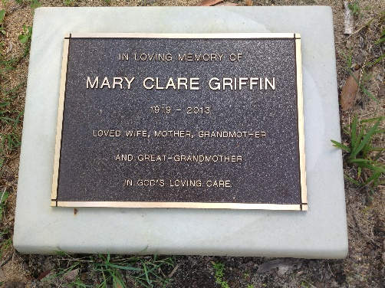 | Concrete lawn base with bronze plaque
Picture 2 | 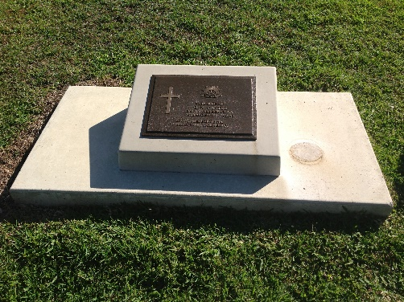 | Concrete base & desk with bronze plaque
Picture 3 | 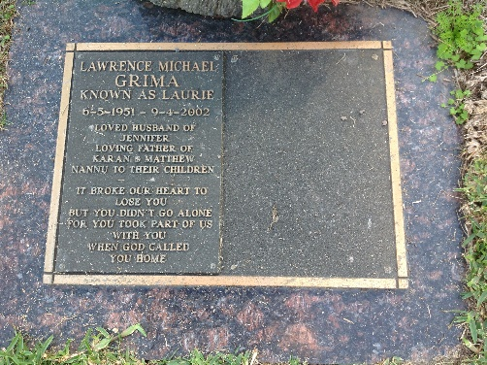 | Detachable plate for existing plaque.  Base plate with existing plaque will already be onsite (as the new plate will be fitted on the blank side. As in this picture)
Picture 4 | 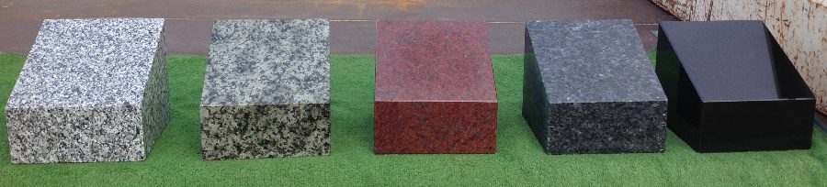  Granite lawn bases are available instead of concrete.  Pictured are the granite sample colours (as they appear above)  Grey / Green / Rose Red / Blue Pearl / Black

